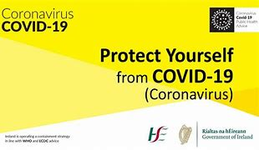

Walk-in Clinic
COVID-19 BOOSTER
VACCINATION

Tuesday 21 December
9.00 am – 6.30 pm
No Appointment Necessary
All welcome!

Location: Enniscorthy Medical Centre
Eircode Y21 R960
Just bring your covid cert and ID!

